Task 1

1 – How The Web Works?

* There are two main components we should mention when we talk about the web Clients and Servers.
* Clients are the typical web user's internet-connected devices such as your computer.
* Servers are computers that store webpages, sites, or apps.

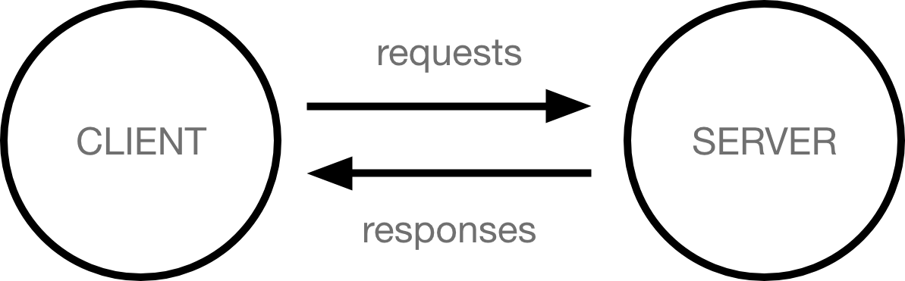

There are also many parts we should talk about like:

* **Your internet connection**: Allows you to send and receive data on the web.
* **TCP/IP**: Transmission Control Protocol and Internet Protocol are communication protocols that define how data should travel across the internet.
* **DNS**: Domain Name System is like an address book for websites.
* **HTTP**: Hypertext Transfer Protocol is an application protocol that defines a language for clients and servers to speak to each other.

When you type a web address into your browser:

The browser goes to the DNS server, and finds the real address of the server that the website lives on.

2.

The browser sends an HTTP request message to the server, asking it to send a copy of the website to the client.

3.

If the server approves the client's request, the server sends the client a "200 OK" message, and then starts sending the website's files to the browser as small parts called data packets.

4.

The browser assembles these small parts into a complete web page and displays it to you as a user.